* 1pm meeting - a free buffet will be available from 12:45pm
* 7:30pm meeting a guest speaker will be invited and attendees receive a drinks voucher for the Court House.
* Please Register to attend the AGM.

Sandwell General UNISON Branch

**Annual General Meeting 2023**

**Tuesday 7th March,**

**1pm and 7:30pm**

Council Chamber at Oldbury Council House

**All members welcome**

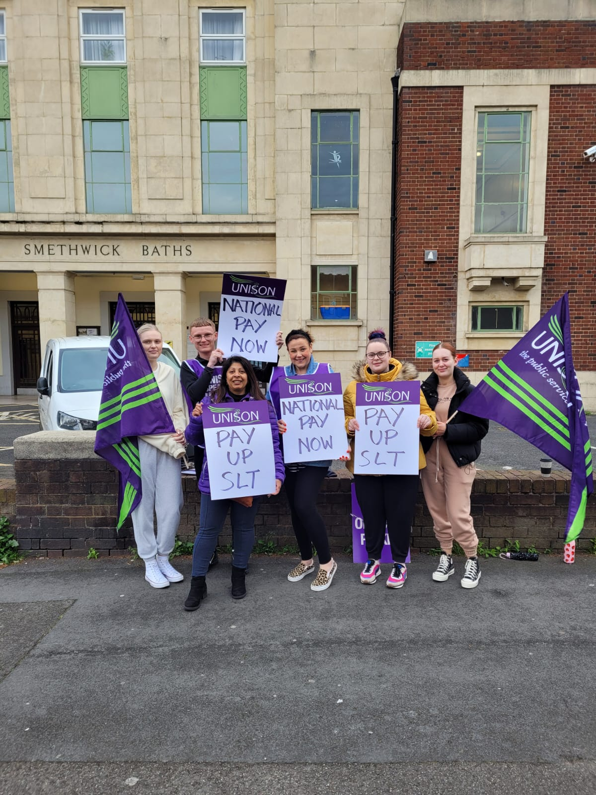

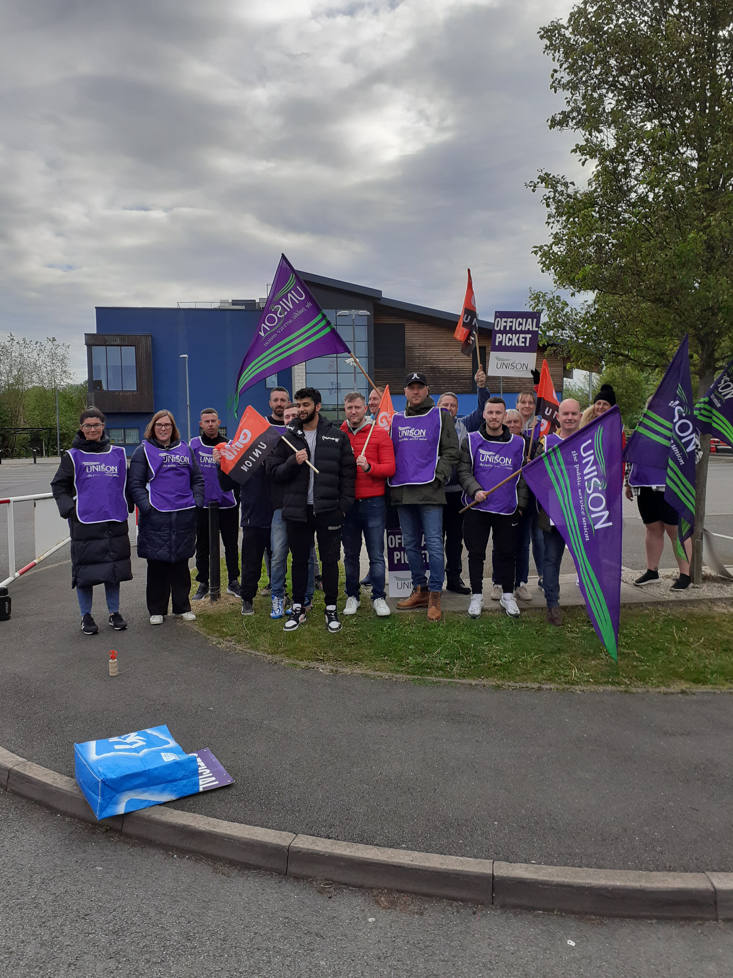

Pictures are from picket lines 10 May 2022, outside Sandwell’s leisure centres. After a 20-month dispute by UNISON, staff at Sandwell Leisure Trust finally returned to national NJC pay, effectively reversing the fire and rehire that took place 2021.